**First Activity on Confidence Interval:**

Q1 Hint: Use z-statistic based CI for normal data

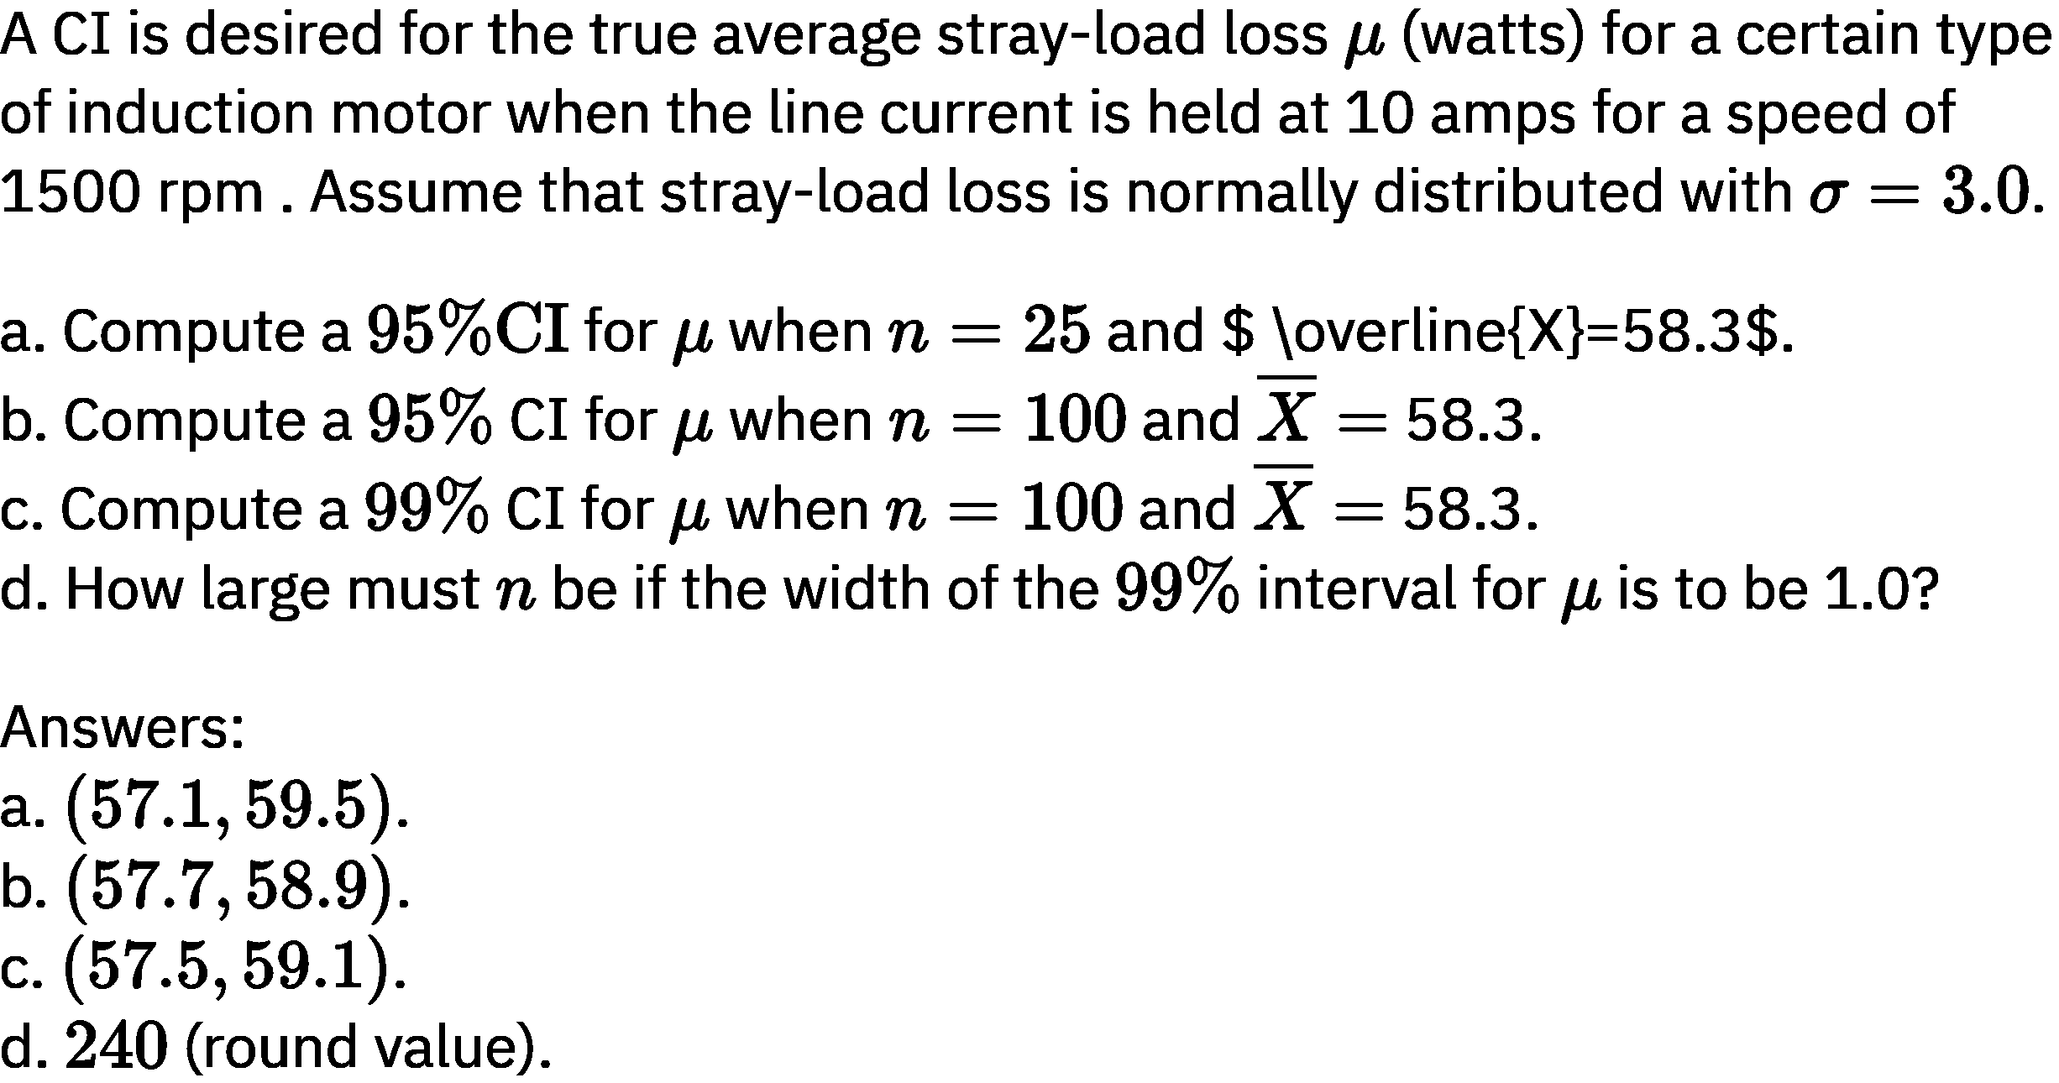

Q2

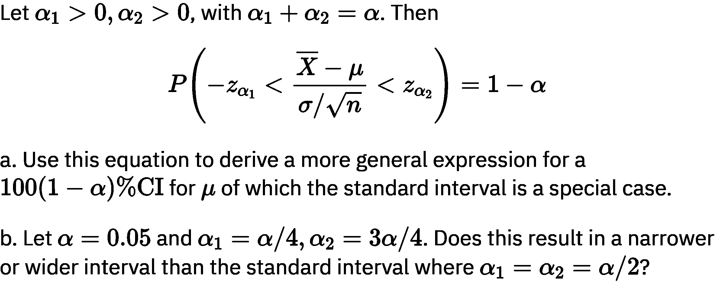

Q3 Hint: Use Approximate CI for normal data

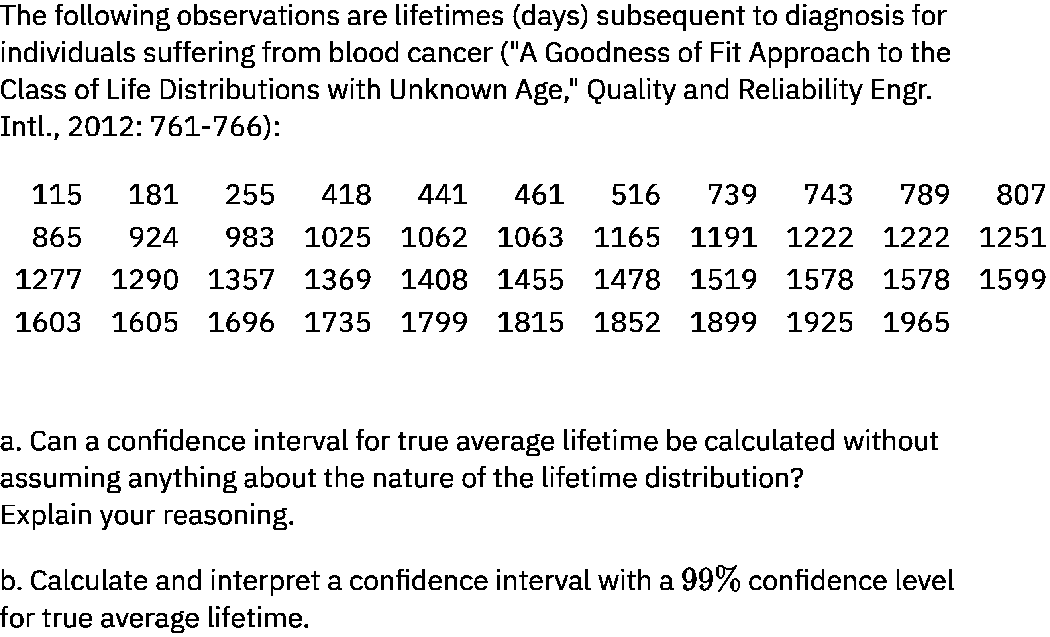

Use data values in MATLAB text form as follows:

Data=[115 181 255 418 441 461 516 739 743 789 807 ...

865 924 983 1025 1062 1063 1165 1191 1222 1222 1251 ...

1277 1290 1357 1369 1408 1455 1478 1519 1578 1578 1599 ...

1603 1605 1696 1735 1799 1815 1852 1899 1925 1965];

Q4 Hint: Use t-statistic based CI for normal data

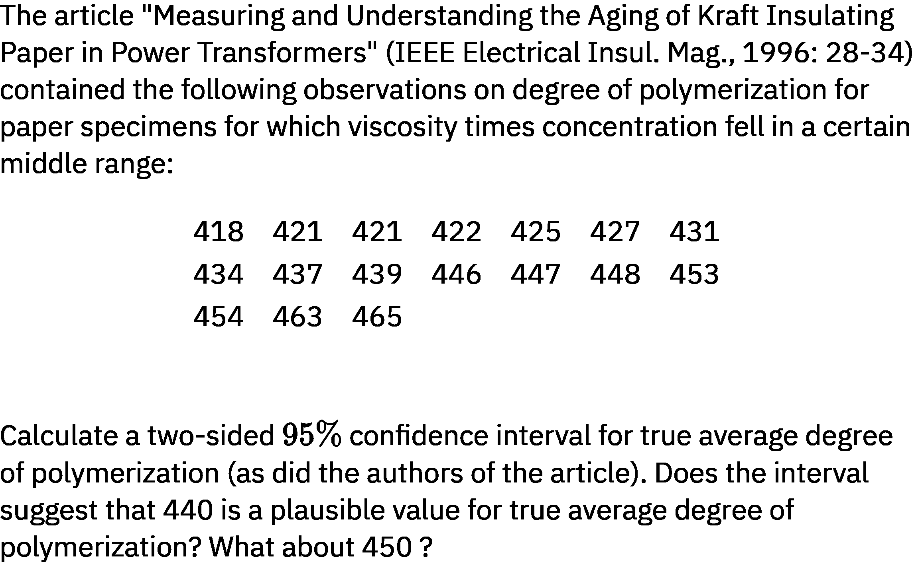

Use data values in MATLAB text form as follows:

Data=[418 421 421 422 425 427 431 434 437 439 446 447 448 453 …

454 463 465];